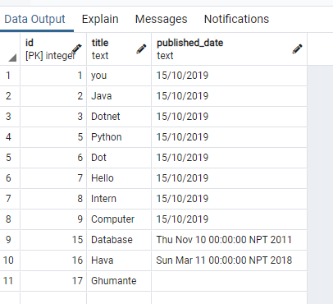**Article table:**

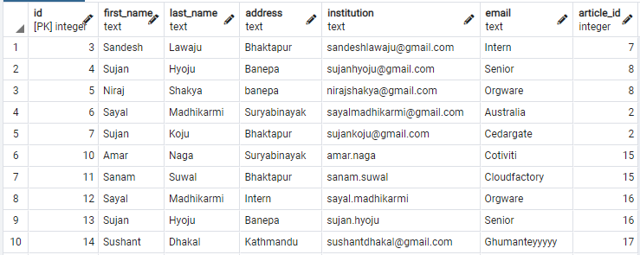**Author table:**

**Read the downloaded file and store in database table**

Algorithm:

1. Read JSON file using FileReader class
2. Parse filereader object into object
3. Converting object to JSON object
4. Add JSON object to the JSON arraylist
5. Iterate JSON array
   1. Create new article object from Article class
   2. Create Object and set it as next iterator
   3. Parse Object to JSON article Object
   4. Get Title from JSON article object and parse it to String and set it to article title
   5. Get Published from JSON object and parse it to String and set it to article published date
   6. Create JSONArray for Author as authorArray
   7. Create AuthorList as authorList
   8. Iterate authorArray
      1. Create author object from Author class
      2. Create Object and set it as next iterator
      3. Parse Object to JSON author Object
      4. Get First Name from JSON author object and parse it to String and set it to author firstName
      5. Get Last Name from JSON author object and parse it to String and set it to author lastName
      6. Get email from JSON author object and parse it to String and set it to author email
      7. Get address from JSON author object and parse it to String and set it to author address
      8. Get institution from JSON author object and parse it to String and set it to author institution
      9. Add the author object to authorList
   9. Set authorList to article

**Display data stored in the database table**

**Algorithm:**

1. Create Statement object and create connection
2. Create ResultSet object and use statement object to execute query for retrieve data from DB

ResultSet rs = statement.executeQuery(“Select * from table_name”);

1. Loop rs until the last row
   1. Initialize id and store value of firstColumn into id
   2. Initialize title and store value of SecondColumn in title
   3. Do this process for all column
   4. Create Statement object and create connection
   5. Create ResultSet object and use statement object to execute query for retrieve data from DB

ResultSet rs = statement.executeQuery(“Select * from table_name”);

* 1. Loop rs until the last row
     1. Initialize id and store value of firstColumn into id
     2. Initialize title and store value of SecondColumn in title
     3. Do this process for all column
     4. Print column value
  2. Print column value

1. End

**Take Article details from user and store in database**

**Algorithm:**

1. Take Article input from user
2. Initialize list of author type so, authorList
3. Take no. of author from user
4. Loop the no. of author
   1. Take author input from user
   2. Store the author to authorList
5. Set the authorlist to article
6. Use PreparedStatement class to connect to DB and execute query
7. Set every column in the query
8. Execute prepared statement Update query and store in anyvalue in integer type
9. Check if there is any row
10. If anyrow is updated then print “Insert data sucessfully”.

**Search and export Article from database using article title**

**Algorithm:**

1. Enter the title of article to be searched
2. Search rows of article using title
3. Use title to find article_id
4. With the help of article_id find the corresponding author
   1. If(article_id match the id that we found from titleSearch)
      1. Retrieve the rows from author table
   2. else
      1. Not found
5. For further processing: we will use the article_id or title

Use title to find article_id

**Search and export Article from database using author detail**

**Algorithm:**

1. Enter email of author used to search
2. Use join query to join author and article table
3. For every row of table
   1. Use condition in the query to check if the email of author is present or not
      1. If email found
         1. Get article_id from article table
         2. Export row from the table
      2. Else
         1. Return Not found
   2. Print the row of table with article
4. Update table

**Delete Article form the database**

**Algorithm:**

1. Take article_id from user as user input
2. Using join query join author and article table
3. Loop whole row
   1. Check if (user input article_id matches any id from table)
      1. If found
         1. Delete from table
      2. Else
         1. Not found
4. Update table

**Delete Article from the database written by an author**

**Algorithm:**

1. Take author detail from user like email as user input
2. Using join query join author and article table
3. Loop whole row
   1. Check if (user input email matches any email from table)
      1. If found
         1. Get article_id from the table
         2. Delete article from table
      2. Else
         1. Not found
4. Update table